Software Functional Requirements Document

for AI-based Tool for Resources Allocation

Imen Souissi

Grand Canyon University: SWE-540

October 19, 2022

Document Version v1.0, v2.0

October 19, 2022

**AUTHORS**

|  |  |  |
| --- | --- | --- |
| **Name** | **Role** | **Department** |
| Imen Souissi | Developer | Software development |

**DOCUMENT HISTORY**

|  |  |  |  |
| --- | --- | --- | --- |
| **Date** | **Version** | **Document Revision Description** | **Document Author** |
| August 24, 2022 | 0.1 | Initial Document Creation | Myself |
| September 24, 2022 | 1.0 | Review document, modify policy section reflecting organizational legal - contractual service agreements for the protection of user information including ISO, PCI DSS | Myself |

**APPROVALS**

|  |  |  |  |
| --- | --- | --- | --- |
| **Approval Date** | **Approved Version** | **Approver Role** | **Approver** |
| September 28, 2022 | 1.0 | Mentor / Adviser | Professor, Mohamed Mneimneh |
| October 19, 2022 | 1.0 | Mentor/Adviser | Professor Ali Wahid |

# Introduction

This project entitled “AI-based Tool for Resources Allocation” may help organization to efficiently allocate its resources using an AI-based technology.

This project was designed to address these issues and consists of two phases. The first phase utilizes an Artificial intelligence technology to implement the core of the project. The second phase will be a testing phase while feeding the model with appropriate data.

## **Purpose of the document**

A functional specification document is a formal document used to describe a product's intended capabilities, appearance, and interactions with users in detail for software developers. It is written usually by product manager. The functional specification is a kind of guideline and continuing reference point as the developers write the programming code.

The Functional Specification Document is a document that provides detailed information on *how* the system solution will function and the requested behavior. This document is created based on the high-level requirements identified in the Users Stories and provides traceability on the functional specifications back to the product backlog. Included in this document will be the detailed functional requirements, including use cases, system inputs and outputs, process flows, diagrams, and mock-ups.

## **Project Scope**

AI-based tool for resources allocation will develop and implement artificial intelligence-based technology for all kind of software organizations with the objective of helping them to successfully optimize their resources allocation - assigning and managing assets in a manner that supports an organization's strategic planning goals - resources can be both human (employees) and electronic (software, computers, other devices).

Briefly, the purpose of this project is to develop an artificial intelligence-based tool that allows software organizations to effectively allocate resources. The goal is to mitigate risks associated to identifying right priorities.

In Scope Features:

* Implement and set up an artificial intelligence-based technology to assign and manage resources (human and electronic).
* Create a SaaS (Software as a Service) based product.

Out of Scope Features:

* This will not include email campaign or any kind of marketing.
* This will not include internal communication automation.

## **Related documents**

|  |  |  |
| --- | --- | --- |
| **Component** | **Name (with link to the document)** | **Description** |
| User Stories Screenshot | GIT Link: https://github.com/Imen-Souissi/User_story | This document includes the user Stories required to implement certain features such as log in, create a proposal, create a labview, start a new case, etc. |

## **Terms/Acronyms and Definitions**

|  |  |  |
| --- | --- | --- |
| **Term/Acronym** | **Definition** | **Description** |
| VM | Virtual Machine | Virtual Machine |
| LabView | An entity that includes a user associated with his requested devices and resources | An entity that includes a user associated with his requested devices and resources |
| Proposal | When A user order the allocation or the purchase of certain resource – hardware or software. | When A user order the allocation or purchase of needed resources. |
| AIBTRA | The term stands for AI-based Tool for Resources Allocation. | The term stands for AI-based Tool for Resources Allocation. |

## **Risks and Assumptions**

According to the article “Design Risk” (n.d.) Broadly speaking, design risk may refer to the following two type of events. Defects in the design that result in the asset being built, but failing to meet the prescribed standards, legal requirements, and any conditions imposed by environmental or other stipulations. Such circumstances mean that the project has to be changed, causing delays and above all cost increases. Defects or failures in the design that result in the project not meeting the service standards requested in the contract, or that result in an increase in operation and maintenance (O&M) costs in order to meet the service requirements.

In this case, risks and factors that could affect the functional design:

- The product is designed to run on cross- platform.

- The product has high priority within the company, therefore the utilization of resources required will be constrained by this.

- The product has to be maintainable for 15 years.

- The product has to be able to serve thousands of companies.

- The product has to be available 24/7.

- The product has to run at a short response latency.

# System/ Solution Overview

The purpose of this project is to develop an artificial intelligence-based tool that allows software organizations to effectively allocate resources. The goal is to mitigate risks associated to identifying right priorities.

## **Context Diagram/ Interface Diagram/ Data Flow Diagram, Application Screen Flow, Sitemap, Process Flow**

**Data Flow Diagram**

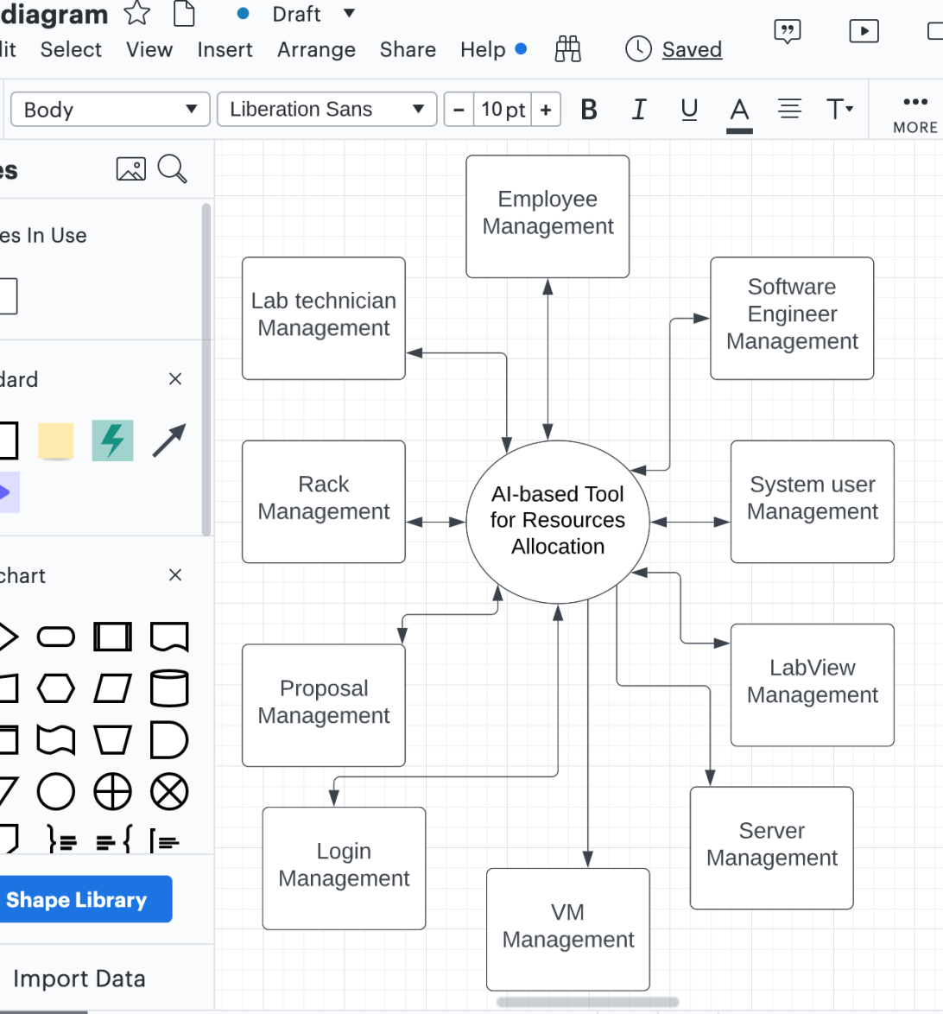

**Sitemap**

According to the article “Why You Should Build A Sitemap Before Designing Your Site” (n.d.) A sitemap can be an effective planning tool for both designers and non-designers alike. It’s a centralized planning tool that can help organize and clarify the content that needs to be on your site, as well as help you eliminate unnecessary pages. And a sitemap, because it’s basically just an outline or flow-chart of the content your site needs, can be created by anyone, regardless of their design skills. Read on for more reasons why a sitemap should be the starting point for your new website design.

**Application Sitemap Using Lucid Chart Tool**

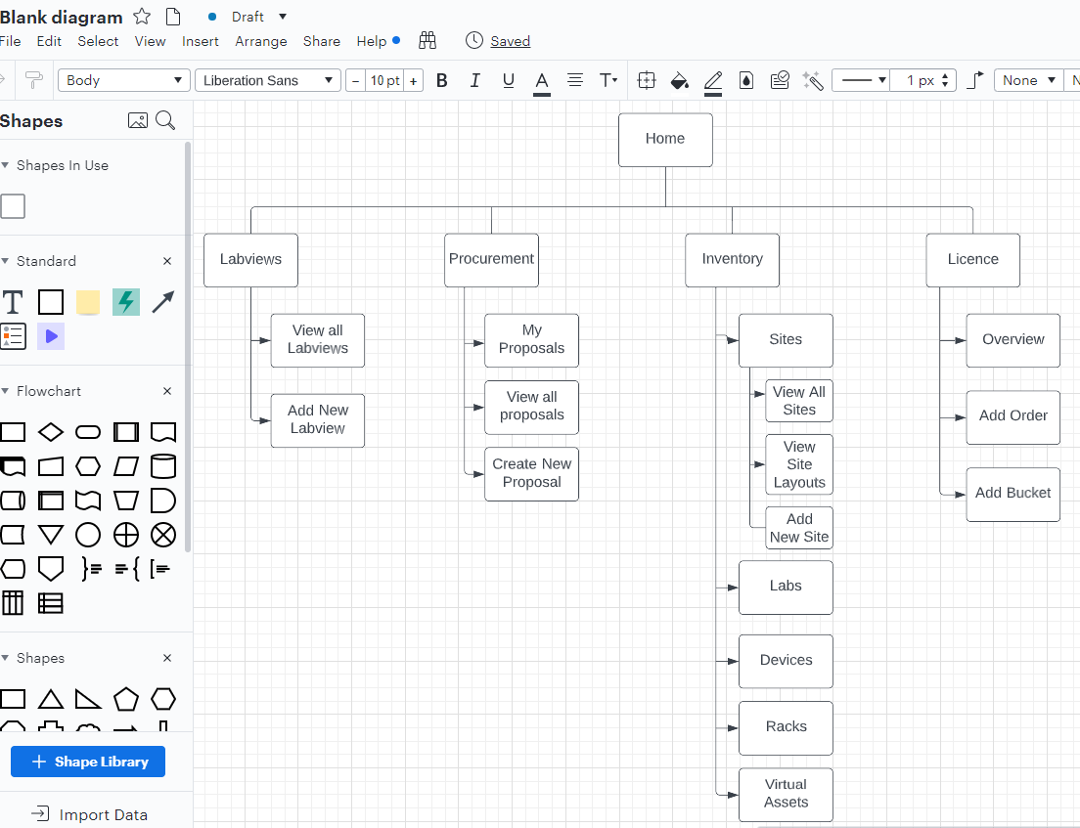

## **Dependencies and Change Impacts**

## System Dependencies:

Require the “IT team” to grant some credentials for the “Jira Company Instance” that the team used to work on previously, in order to track previous versions of the software that I’m trying to improve.

## Change Impacts:

The whole company application used for Management resources will be impacted by the deployment of the new version of the software.

1. **Functional Specifications**

The functional specifications describe what the end-users want the system to do and not how the system works. They include input, output, control logic, storage, data handling, and security requirements. That is, the functional specifications specify the functionality of a software system. It typically includes the specifications for all or most of the following:

**User interface design and navigation**: The user interface should be user friendly and easy to use.

**Data input and output formats:** This is an MVC application, forms are part of the input system, in order to add or edit any existing resource you have to fill out a form (View layer).

**File formats, data types, and constraints**

**Database design, data access methods, and constraints:**

Apache is the web server that processes requests and serves web assets and content via HTTP. MySQL is the database that stores all your information in an easily queried format. PHP is the programming language that works with Apache to help create dynamic web content. Programmatic interfaces for accessing external systems:

**Error handling procedures - Communication protocols for interfacing with external systems:** This includes log errors, process time stamping, or handle missing values.

**Security requirements** Log in into the allocation application requires special credentials these credentials have different categories including admin, engineer, lab technician, Manager..., authentication is always required, authorization is granted by admin.

| High-Level Functions | Detailed Functions |
| --- | --- |
| Database: We use it to hold the data. | We have used a relational database: MYSQL - that is based on a tabular design. |
| Classes: For example, Labview, Proposal, Inventory, etc. | We have used here PHP OOP classes as well as the MVC paradigm that gives each module (class) three layers Model, View and Controller. |
| User Interfaces: To create proposal, labview, add new products, order or allocate devices, etc. | We have used an MVC paradigm framework which is Zend Framework2 |
| External Interfaces: To send notification and information to users via emails, text message, voice mail, and anything else we can think of. | We can use Mailchimp as external interface for this kind of notifications. |

## **Architecture**

The user uses his given credentials to get access, then he requested certain service such as allocating a new device, the server sends the request to the controller then the controller will ask the model layer about the availability of the device, the model responsible for adding devices will query the database then return the availability to the controller which will contact the view layer for a presentation and html wrap for that action.

**System diagram for the Application Using Lucid Chart Tool**

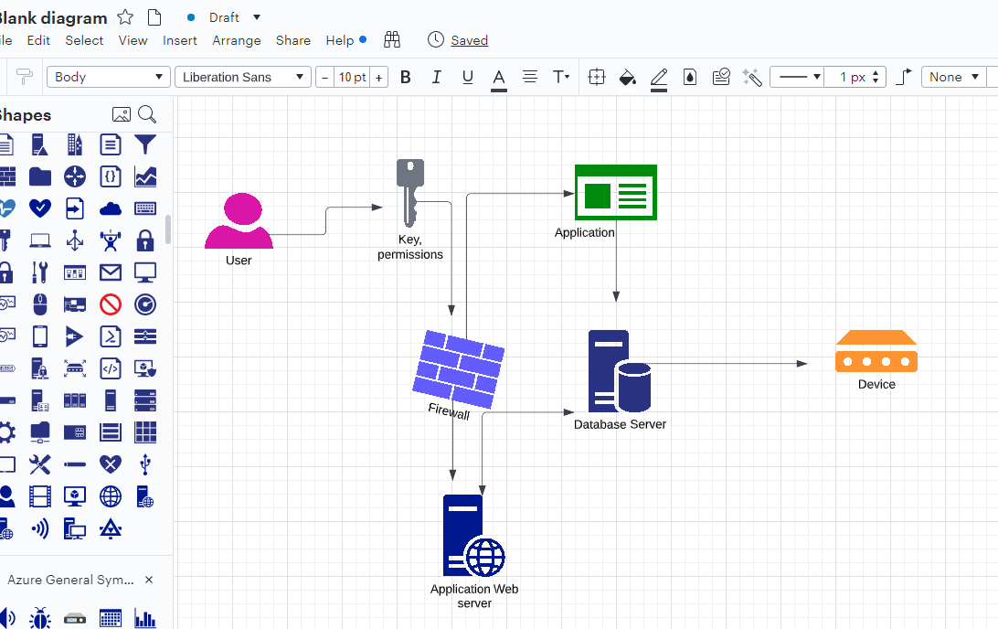

## Purpose/ Description

The functional requirements document (FRD) is a formal statement of an application's functional requirements. It serves the same purpose as a contract. The developers agree to provide the capabilities specified. The client agrees to find the product satisfactory if it provides the capabilities specified in the FRD.

## Mock-Up

According to Klein (2017)mockups are quick drawings of user interfaces (UIs) -this typically means browser screens. They typically show the layout of your webpage and the various buttons and options presented to users. They show you where these buttons and options are placed on the page, what text fields or buttons exist, and any other features of your website. Having solid mockups will *help your web developer build faster and with fewer defects, meaning less rework (saving you time and money towards the end of your development experience)*. They also help you by giving you a sneak peek into what the web developer was going to build, and they enable conversations between you and your web developer so that you can get exactly what you want.

**Home page Mockup Using Figma: Figure 1**

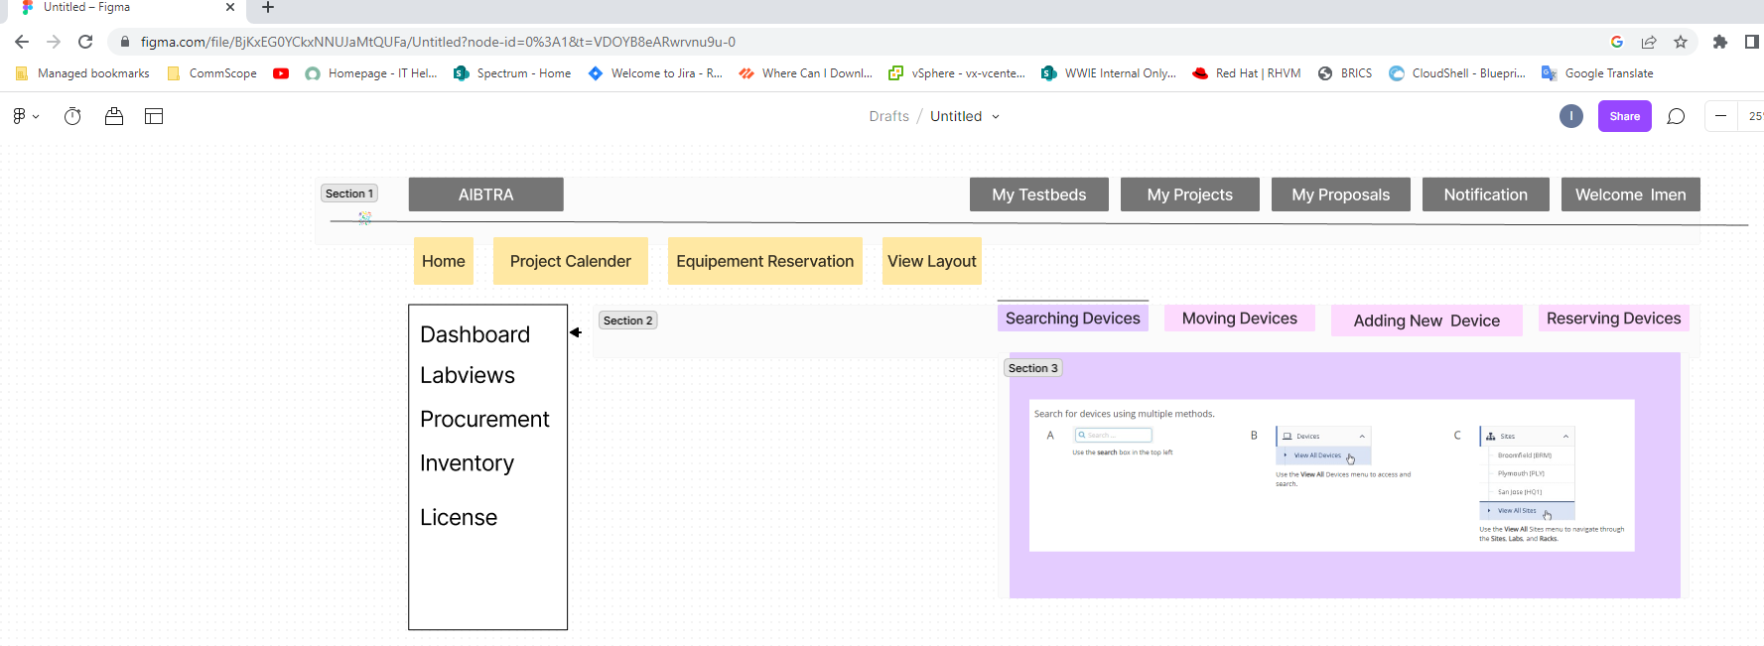

**Home page Mockup Using Figma: Figure 2**

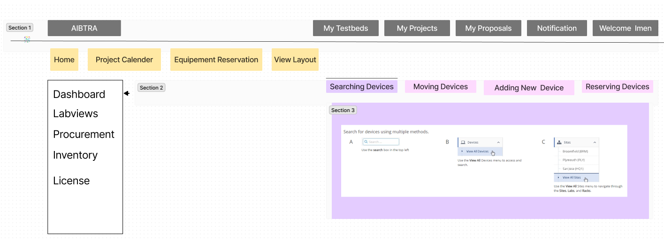

## Functional Requirements

| ID | Functional Requirement |
| --- | --- |
| FR-1 | AIBTRA application shall have an index page that lists the purpose of the organization. |
| FR-2 | AIBTRA application home page shall list all the modules of the application such as Labviews, Procurement, Inventory, License, etc. |
| FR-3 | AIBTRA application shall have a page called “Map View” where users can have a top-down view of labs and floor plans. |
| FR-4 | Users of AIBTRA application shall be able to see all the roles inside the organization as well as related permissions and resources, some users might have the credentials to create new roles and assign them to other users or groups within the same organization. |
| FR-5 | Users of AIBTRA application shall be able to have an overview on all the products that the organization had procured such as the product name, the quantity, the product cost, the type of the product – either Hardware or Software – the quantity, the manufacturer, the model as well as the classification. |
| FR-6 | Users of AIBTRA application shall be able to add new product, add configurable product as well as import products from a CSV, XLS, or XLSX file. |
| FR-7 | Users of AIBTRA application shall be able to Excel export all the existing products. |
| FR-8 | Users of AIBTRA application shall be able to have an overview on all the created proposals such as proposal Id, Name, Status – In progress, pending or completed – department, quarter, Revision and Total cost. |
| FR-9 | Users of AIBTRA application shall be able to add new proposal and import proposals from a CSV, XLS, or XLSX file. |
| FR-10 | Users of AIBTRA application shall be able to Excel export all the existing proposals. |

1. **System Configurations:**

To build this application I have started with creating a “Zend framework 2” project, this framework like all the other application frameworks supplies tools and ready configurations that gives shape and structure to the overall application, besides it requires a specific directories/files hierarchy for the three main components of this MVC application which are Model, View and Controller, the “Zend framework 2” documentation provides all the required elements. On the top of that it provides a copy/paste ready configurations for the module.php, module.config.php, autoloader files, etc. Almost all the required files for a new module are provided by the framework which makes the configuration process a bit smoothy.

1. **Other System Requirements**

# The stakeholders expect the system to send emails as a formal way to notify the engineering production teams – our system users – about the due date of the utilization of the resource that they allocated, so they can factory reset it so it can restart the same cycle.

# The stakeholders expect the application to do all the procurement contracts within united states or internationally if the required resource is not available internally.

# The stakeholders expect the proposal, allocation and procurement to obey to the timelines.

1. **Reporting Requirements**

# According to the article “What are Reporting Requirements: Definition, Tools & Documentation Guide” (n.d.) A requirements report is a document that outlines the necessary elements of a project or system. It includes information on the purpose, scope, and goals of the project, as well as the stakeholders involved. The requirements report also details what needs to be done in order to complete the project successfully.,

# Briefly, Reporting Requirements are related to regular reports, analytics or visualization of information.

|  |  |  |
| --- | --- | --- |
| Req. # | Requirement Description | Priority |
| 1 | In order to be able to allocate resources, users of the system have to get credentials that allow them to do so. | High |
| 2 | Only lab technician users can search for available devices and assign them to the required project to make it easy for the team of engineers to start their project right away. | High |
| 3 | In case of absence of a required resource, an audit specialist has to use the system in order to procure the right product from a given link. | High |
| 4 | The audit specialist has to contact the vendor and ask for a quote, and accordingly, he might use the system to create a new contract between the organization and this vendor. | High |
| 5 | Each used device should be tracked by project ID and users IDs, in order to keep track of the used resources and for audit purposes. | High |
| 6 | In case of a non-returned device, the lab technician user has to notify the last allocator of the devise, in order to track it. | High |
| 7 | Users can export the list of devices, labviews, proposals in Excel files, and similarly they can import existing devices, labviews, proposals in Excel files. | Medium |

1. **Integration Requirements**

# Integration requirements indicate the integration of organizations, processes, data or systems. The following is the most important features of our system integration requirements:

#  Application integration is done through SOAP and REST services.

#  Large capacity for data integration and storage through a data lake or cloud-based data warehouse

#  Integration will be able to support the present and coming data velocities whether batch or streaming data

#  Event-based integration over clock-driven integrations

#  A document-centric data integration strategy

#  Hybrid integration, including for both cloud-to-cloud and cloud-to-ground scenarios.

#  Integration must be accessible via REST/SOAP APIs

#  Instead of location, new integrations must be focused on connectivity for speed and agility

## **Exception Handling/ Error Reporting**

|  |  |  |  |
| --- | --- | --- | --- |
| **Exception/Error ID** | **Error** | **Cause** | **Solution Strategy** |
| 1 | Update Zend framework 2 | Installing a dependency (Mail sending) that is not compatible with Zend Current version | Update the Package as requested |
| 2 | The auto generated labviews should be archived not appear in the list of the created labviews. | Architectural defect | Implement new feature that can support this functionality |

1. **References****:**

Design Risk. (n.d.). https://ppp-certification.com/ppp-certification-guide/114-design-risk#

What are reporting requirements: Definition, tools & documentation guide. (n.d.). https://visuresolutions.com/blog/reporting-requirements/#

Why you should build a sitemap before designing your site. (n.d.).

https://neilpatel.com/blog/build-a-sitemap/#

1. **Open Issues**

|  |  |  |  |  |  |  |  |
| --- | --- | --- | --- | --- | --- | --- | --- |
| Issue **ID** | **Issue** | **Raised By** | **Raised On** | **Solution/ Decision** | **Resolved By** | **Resolved On** | **Status** |
| 1 | Duplication of a report that has to be auto - generated when creating a new labview | Previous Developer | 2021 | Spot the code then try to apply the Separation of Interest Principle | Myself | 2022 | Processing |
| 2 | The auto generated labviews should be archived not appear in the list of the created labviews. | Lab Team | 2021 | Implement new feature that can support this functionality | Myself | 2022 | Processing |

# 

# Appendix

**AIBTRA:** Stands for AI-based Tool for Resources Allocation.

**AIBTRA users:** They are the team of engineers that need to allocate some specific resources to start a project or perform certain task.

**A proposal:** It is a request of hardware material - such as servers, switchers, etc., - or software tool – such as license, ticket, etc. - this proposal needs to be reviewed by certain department and then either gets approved - in this case a labview is created - or denied.

**A LabView:** It is the output of an approved proposal - requesting certain hardware to work on certain case by a team of engineers.

**Lab Team:** The group of technicians that work in the laboratory.

**VM:** This term refers to the virtual machine.

**VMC:** It stands for View Model Controller paradigm.